# Name - Aman Maurya

# Roll No. - 223CS3153

# Course - M. Tech (Year-I)

# Branch - CSE (Software Engineering)

# Assignment - (3) Selenium Webdriver

# Google Search

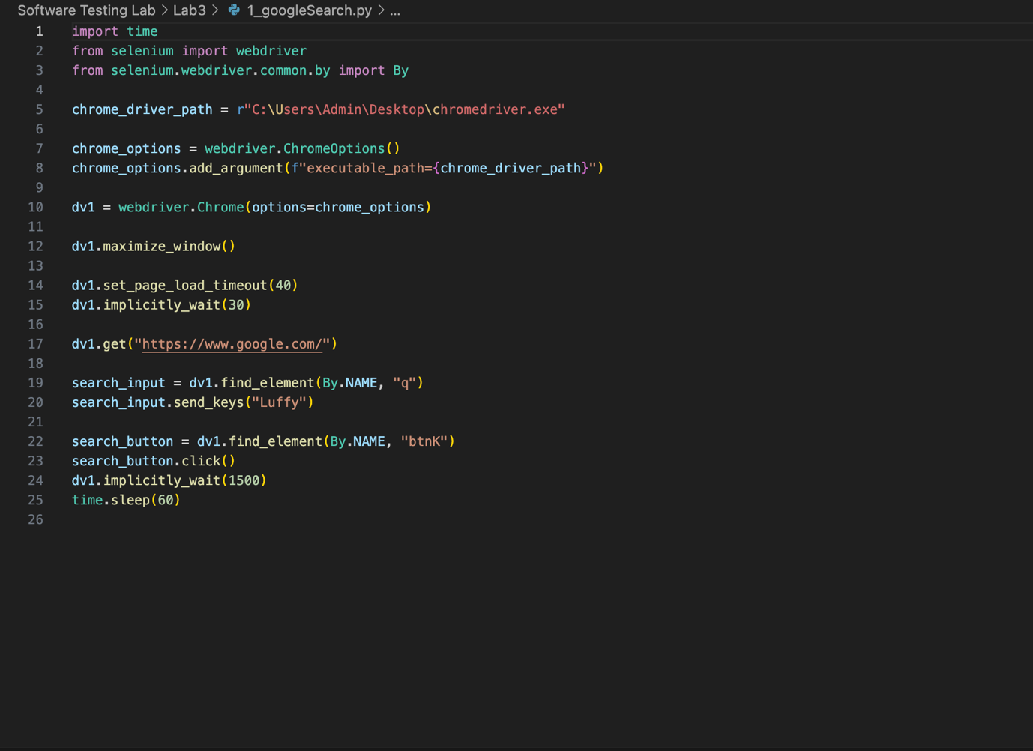

# Coursera Search

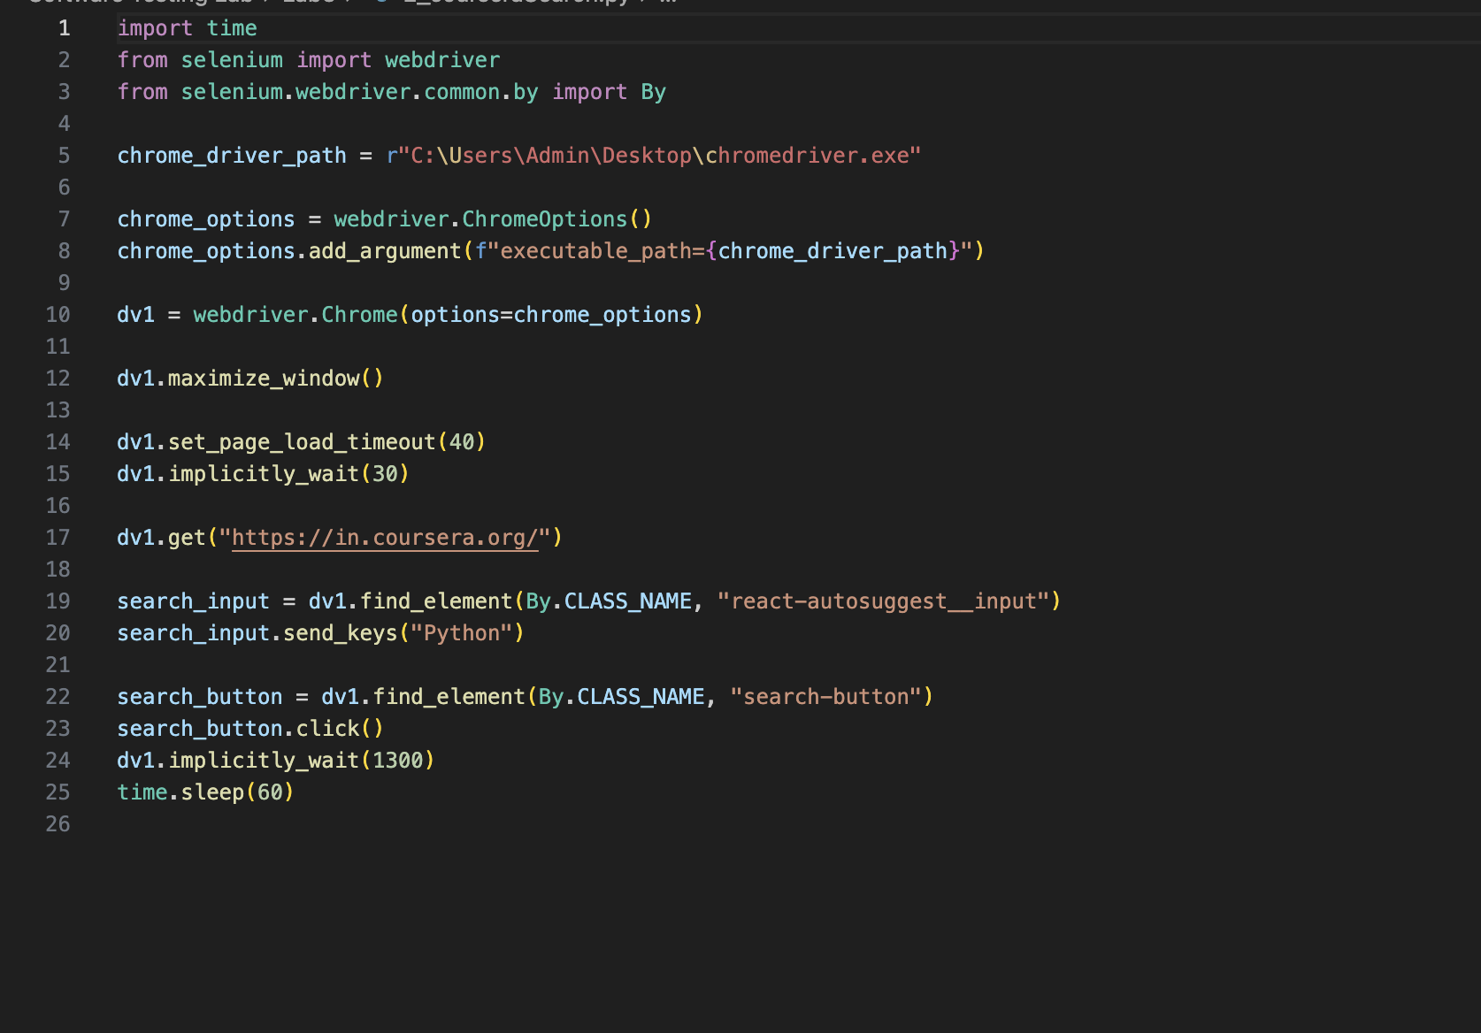

# Geeks For Geeks

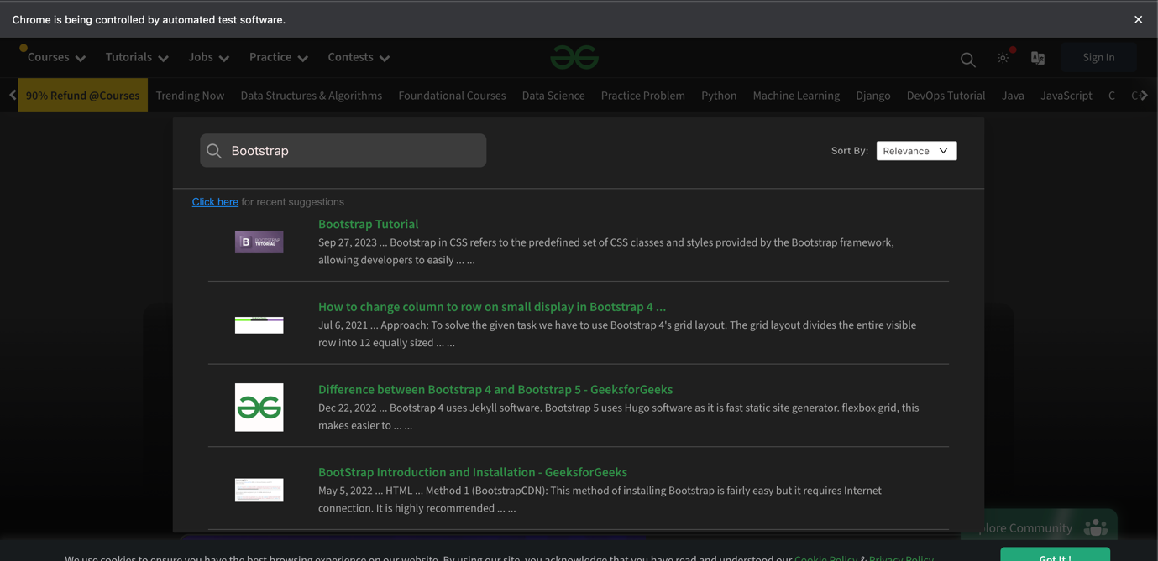

# Youtube

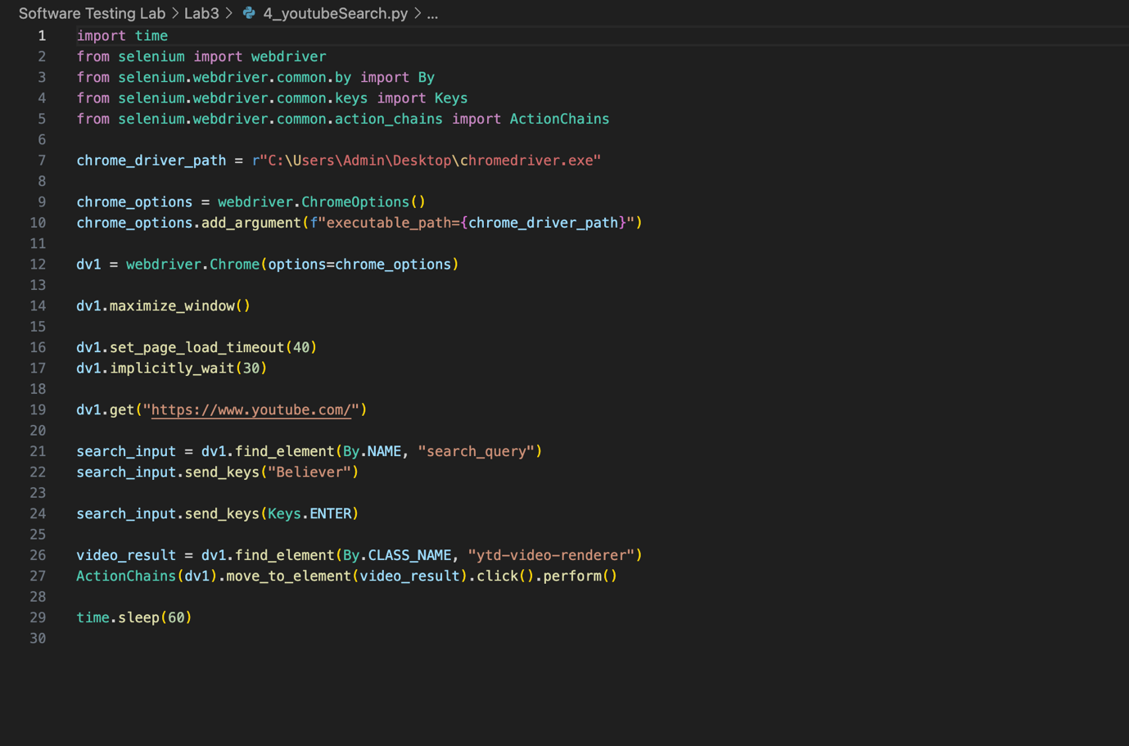

# Wikipidea

# Freepik Download

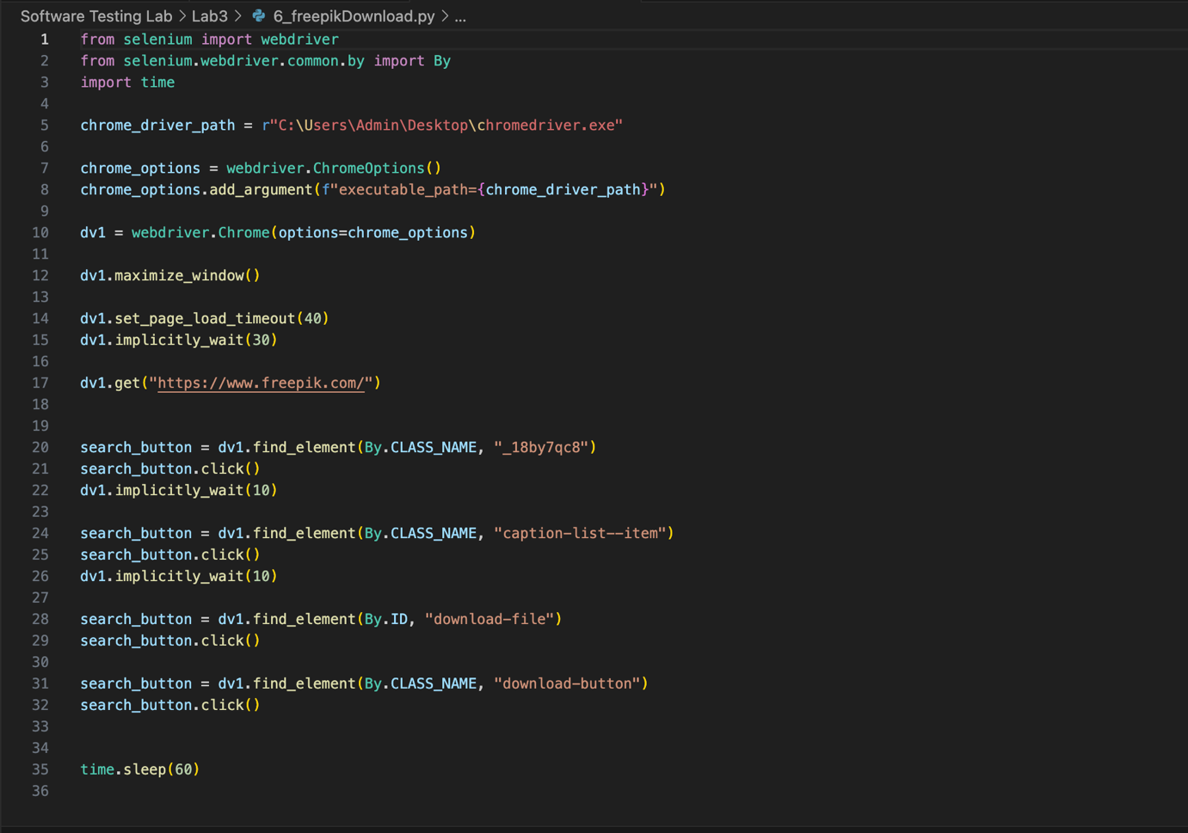

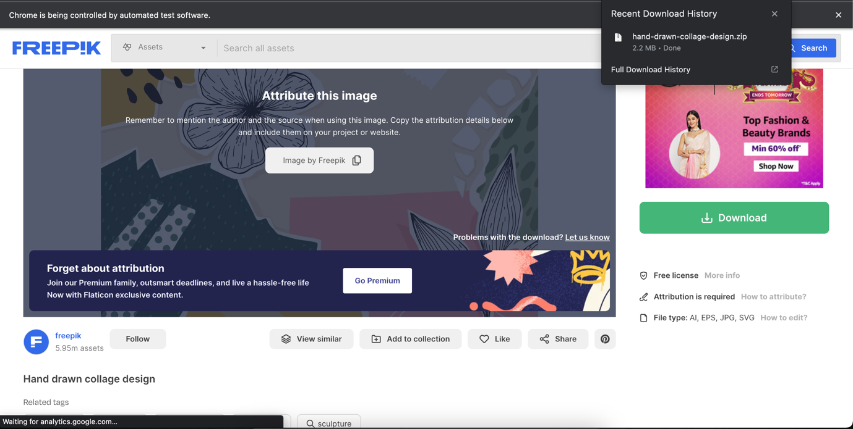

# Pexel Download

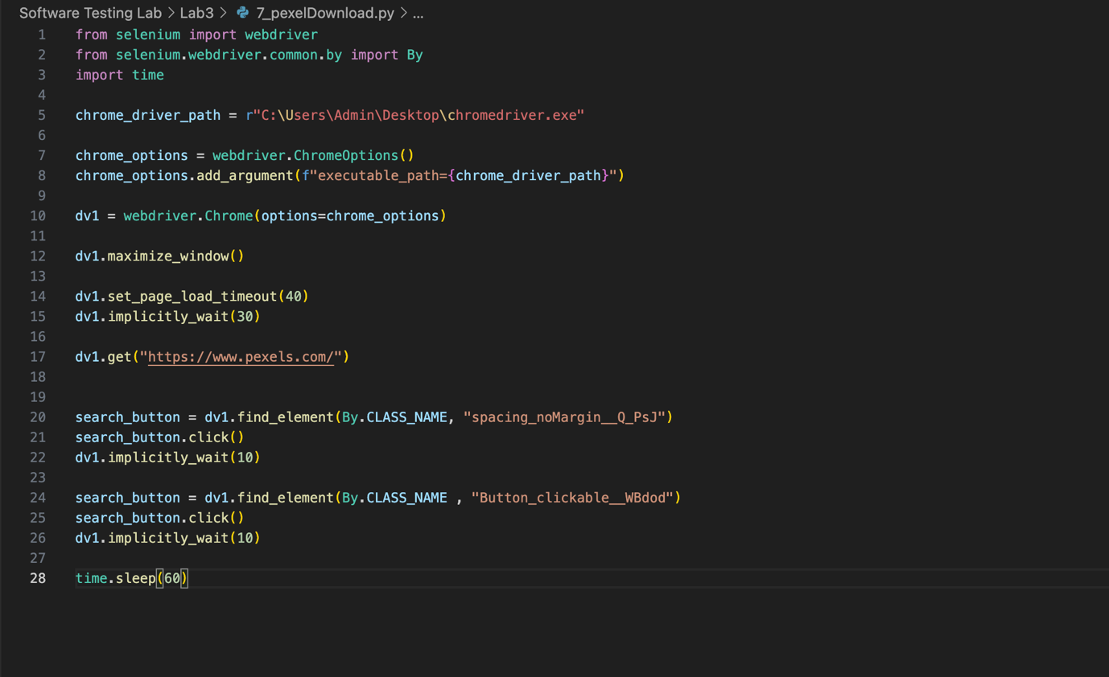

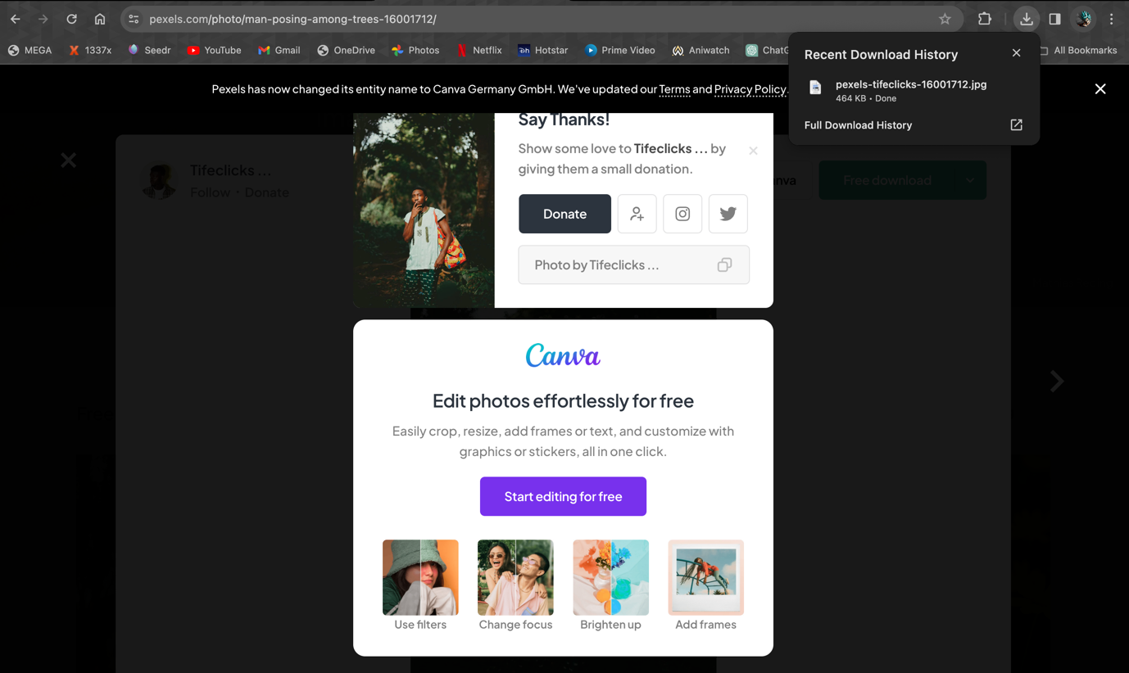

# W3Schools

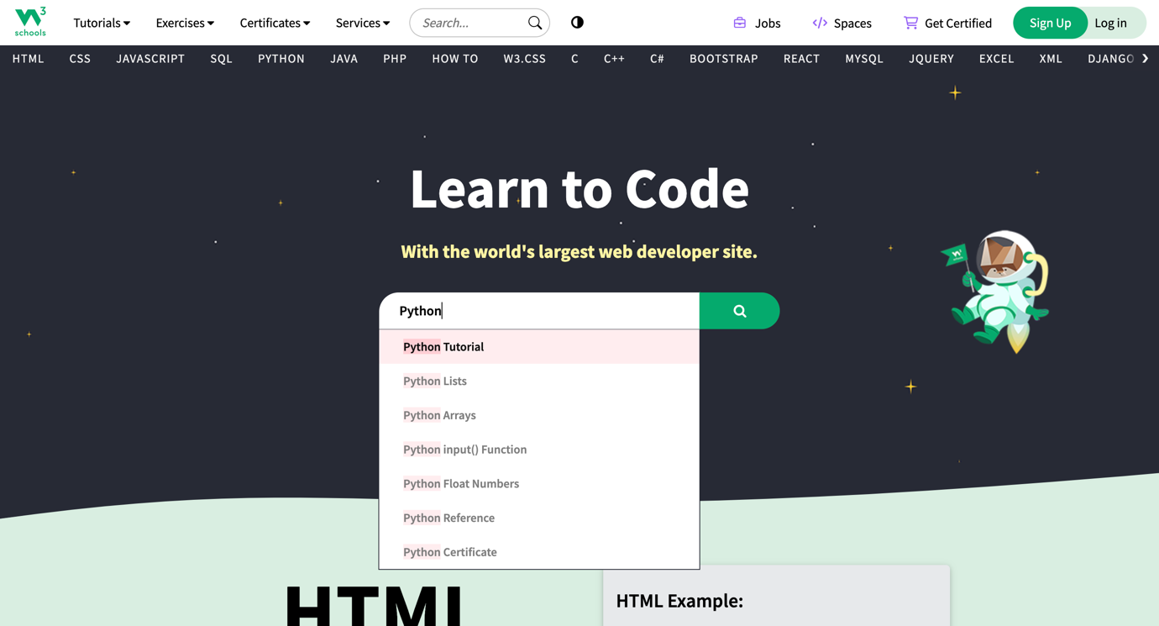

# Yahoo Search

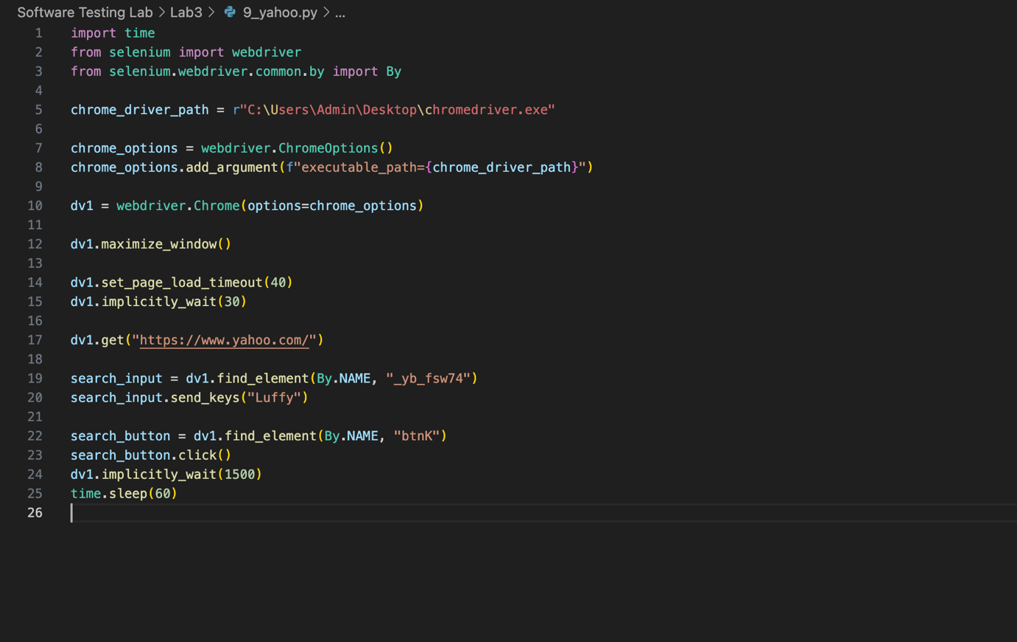



# LeetCode

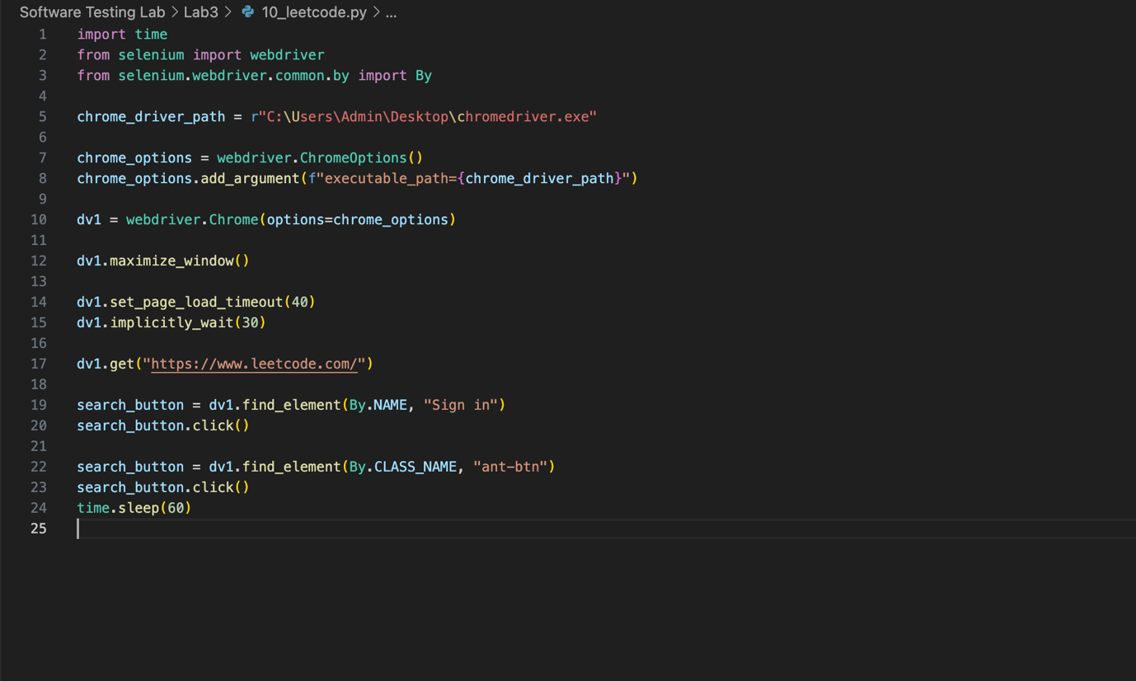

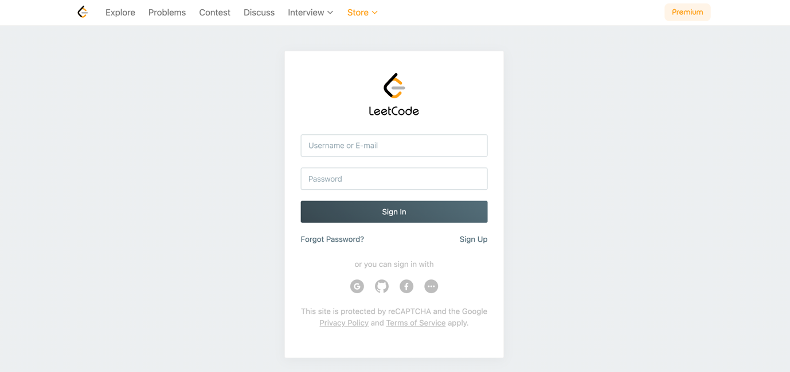

# NITRIS Result

